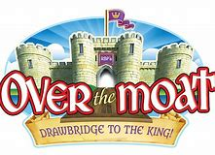

Pleasant Valley Baptist Church

Vacation Bible School

June 25-29, 2018

Enter child’s birth date & age:
Enter child’s name (last, first):

Enter grade of school:
Sex (circle one): Male Female

Enter child’s address (street address, city, state):
Phone numbers:
Cell -
Home -

Email Address:
Mother/Guardian:
Father/Guardian:
Emergency Contact Information 2:
(Name, relationship to child, contact number)

Emergency Contact Information 1:
(Name, relationship to child, contact number)

Health Information (Allergies/Medical Condition):
Authorizations (please select all that apply):
⃝ I give authorization for my child to have his/her face painted.
⃝ I give authorization for my child to have his/her picture taken by camera, cell phone, or video.
⃝ I authorize PVBC to use any pictures of my child for flyers, newspaper, Facebook, or any other form of advertising events.

Sign and Date:

